A Project Report

On

STOCK PRICE PREDICTION MODEL

Submitted for the partial fulfilment of the requirement

for the award of the Degree of

Bachelor in Technology
In

Computer Science Engineering with specialization in Big Data

Analytics

By

Mohak Mahajan
Samarth Joshi
Sankalp Chaturvedi

Under the Guidance of

Mr. Rohit Kamboj
(IBM faculty, Department of CSE, DIT University)


DIT UNIVERSITY, DEHRADUN, INDIA

April, 2019



DECLARATION

This is to certify that the Project entitled “Stock Price Prediction Model” in partial fulfillment of the requirement for the award of the Degree of Bachelor In Technology in Computer Science Engineering with specialization in Big Data Analytics(IBM), submitted to DIT University, Dehradun, Uttarakhand, India, is an authentic record of bonafide work carried out by me, under the guidance of Mr. Rohit Kamboj. The matter embodied in this Project/Thesis/Dissertation has not been submitted for the award of any other degree or diploma to any University/Institution.

Students Name & Signature: Mr. Rohit Kamboj, IBM Faculty
Signature:

Dr. Vishal Bharti | <Name>
Professor HOD | Controller of Examination
CSE Department | Signature
Signature

Date:

Place: Dehradun

CERTIFICATE

This is to certify that the Project entitled “Stock Price Prediction Model” in partial fulfilment of the requirement for the award of the Degree Bachelor In Technology in Computer Science Engineering with specialization in Big Data Analytics(IBM), submitted to DIT University, Dehradun, Uttarakhand, India, is an authentic record of bonafide research work carried out by Mr. Mohak Mahajan, Roll No 160113022, Mr. Samarth Joshi, Roll no 160109015 and Mr. Sankalp Chaturvedi, Roll No 160109046 under my supervision/ guidance.

Signature and Name of
Supervisor(s)/Guide

Date:

Place: Dehradun

ACKNOWLEDGEMENT

We would like to take opportunity to express our humble gratitude to Mr. Rohit Kamboj (IBM faculty, DIT University), under whom we executed this project. His constant guidance and willingness to share his knowledge and experience made us understand this project and its manifestations in great depths and helped us to complete the assigned tasks.

We are also thankful to our classmates who have helped us in collecting the data for training the model.

Mohak Mahajan
Roll no. 160113022

Samarth Joshi
Roll no. 160109015

Sankalp Chaturvedi
Roll no. 160109046

ABSTRACT

This project seeks to utilize Deep Learning models, Long-Short Term Memory (LSTM) Neural Network algorithm, to predict stock prices. For data with timeframes recurrent neural networks (RNNs) come in handy but recent researches have shown that LSTM, networks are the most popular and useful variants of RNNs.
We will use Keras to build a LSTM to predict stock prices using historical closing price and
trading volume and visualize both the predicted price values over time and the optimal
parameters for the model.

TABLE OF CONTENTS

Title

Page No.

DECLARATION.....................................................................................................................ii

CERTIFICATE………...…………………………………………………………………… iii
ACKNOWLEDGEMENT…………………………………………………………………...iv

ABSTRACT…………………………………………………….………………………….... v
TABLE OF CONTENTS…………………………………….……………………………. .vi

LIST OF FIGURES.................................................................................................................. |  | viii
CHAPTER 1 INTRODUCTION
1.1 | Purpose ................................................................................................................................. | 9
1.2 | Objective.............................................................................................................................. | 9
1.3 Motivation……………………….…………………………………………………….….9
1.4 | Scope of Study………………………………………………………………………..….10
1.5 Research Methodology……………………………………………………….…………...10
CHAPTER 2 OVERALL DESCRIPTION
2.1 | Definition of Terms…………....................................................................................……11
2.2 | Stock Prediction Concepts…….………..............................................................................11
2.3 | Libraries……………………………………………………………………………….....12
2.4 | Overview of existing tutorials……………………............................................................. | 13
2.5 | Expected Output of Stock Prediction…………………………………………………….14
CHAPTER3 SYSTEM DESIGN AND TECHNICAL OVERVIEW
3.1 | Methodology…………………………………………………………………………….15
3.2 | General Overview……………………………………………………………………….17
3.3 System Architecture……………………………………………………………………...18
3.4 Implementation Methodology……………………………………………………………18
3.5 | Use Case Diagram and Data Flow Diagram…….………………………………………...20
3.6 | Tools Used………………………………………………………………………………...21
3.7 | Hardware and Software Requirements………….………………………………………...21
CHAPTER4 SYSTEM FEATURES
4.1 | Data Preparation........................................................................................... | 22
4.2 | Model Construction…………………………................................................... | 25
CHAPTER 5 OTHER NONFUNCTIONAL REQUIREMENTS
5.1 | Performance Requirements................................................................................................ | 28
5.2 Advantages and Disadvantages…………………………………………………….….….28

5.3 Challenges……………………………………………………………………………….29
5.4 Applications……………………………………………………………………………...29
5.5 Software Quality Attributes……………………………………………………………...29

Title Page No.

CHAPTER 6 CONCLUSION AND FUTURE WORK
6.1 Conclusions 31

6.2 Scope for Future Work 31

REFERENCES ……………………………………………………..………………………32

LIST OF FIGURES

Figure Page no.
Fig 1…………………………………………………………………………………16
Fig 2…………………………………………………………………………………16
Fig 3…………………………………………………………………………………17
Fig 4…………………………………………………………………………………18
Fig 5…………………………………………………………………………………19
Fig 6 Use Case Diagram…………………………………………………………...20
Fig 7 Data Flow Diagram………………………………………………………….20
Fig 8…………………………………………………………………………………23
Fig 9…………………………………………………………………………………24

CHAPTER 1

INTRODUCTION

1.1 PURPOSE

The challenge of this project is to accurately predict the future closing value of a given stock across a given period of time in the future. For this project I will use a Long Short-Term Memory networks usually just called “LSTMs” to predict the closing price of the S&P 500 using a dataset of past prices.

1.2 OBJECTIVE

This project seeks to utilize Deep Learning models, Long-Short Term Memory (LSTM) Neural Network algorithm, to predict stock prices. For data with timeframes recurrent neural networks (RNNs) come in handy but recent researches have shown that LSTM, networks are the most popular and useful variants of RNNs.
We will use Keras to build a LSTM to predict stock prices using historical closing price and
trading volume and visualize both the predicted price values over time and the optimal
parameters for the model.

1.3 MOTIVATION

Predicting how the stock market will perform is one of the most difficult things to do. There are so many factors involved in the prediction – physical factors vs. psychological, rational and irrational behaviour, etc. All these aspects combine to make share prices volatile and very difficult to predict with a high degree of accuracy.
Can we use machine learning as a game changer in this domain? Using features like the latest announcements about an organization, their quarterly revenue results, etc., machine learning techniques have the potential to unearth patterns and insights we didn’t see before, and these can be used to make unerringly accurate predictions.

1.4 SCOPE OF STUDY

We will work with historical data about the stock prices of a publicly listed company. We will implement a mix of machine learning algorithms to predict the future stock price of this company, starting with simple algorithms like averaging and linear regression, and then move on to advanced techniques like Auto ARIMA and LSTM.

1.5 RESEARCH METHODOLOGY

Investment firms, hedge funds and even individuals have been using financial models to better understand market behavior and make profitable investments and trades. A wealth of information is available in the form of historical stock prices and company performance data, suitable for machine learning algorithms to process.
Can we actually predict stock prices with machine learning? Investors make educated guesses by analyzing data. They'll read the news, study the company history, industry trends and other lots of data points that go into making a prediction. The prevailing theories is that stock prices are totally random and unpredictable but that raises the question why top firms like Morgan Stanley and Citigroup hire quantitative analysts to build predictive models. We have this idea of a trading floor being filled with adrenaline infuse men with loose ties running around yelling something into a phone but these days they’re more likely to see rows of machine learning experts quietly sitting in front of computer screens. In fact, about 70% of all orders on Wall Street are now placed by software, we're now living in the age of the algorithm.

CHAPTER 2

OVERALL DESCRIPTION

2.1 DEFINITION OF TERMS:

The goal of this project was to study time -series data and explore as many options as possible to accurately predict the Stock Price. Through my research i came to know about Recurrent Neural Nets (RNN) which are used specifically for sequence and pattern learning. As they are networks with loops in them, allowing information to persist and thus ability to memorise the data accurately. But Recurrent Neural Nets have vanishing Gradient descent problem which does not allow it to learn from past data as was expected. The remedy of this problem was solved in ​Long-Short Term Memory Networks usually referred as LSTMs. These are a special kind of RNN, capable of 9 learning long-term dependencies.
In addition to adjusting the architecture of the Neural Network, the following full set of parameters can be tuned to optimize the prediction model:
• Input Parameters
• Preprocessing and Normalization (see Data Preprocessing Section)
• Neural Network Architecture
• Number of Layers (how many layers of nodes in the model; used 3)
• Number of Nodes (how many nodes per layer; tested 1,3,8, 16, 32, 64, 100,128)

2.2 STOCK PREDICTION CONCEPTS:

The stock market is one of the most well-known infrastructures through which anyone can potentially make a fortune. If anyone could crack the code to predicting what future stock prices are, they’ll practically rule the world.
There’s just one problem. It’s pretty much impossible to accurately predict the future of the stock market. So many analysts, so many researchers, so many super smart people have tried to figure it all out. No one has been able to garner consistent results. No one.
The recurrent neural network (RNN) is a type of artificial neural network with self-loop in its hidden layer(s), which enables RNN to use the previous state of the hidden neuron(s) to learn the current state given the new input. RNN is good at processing sequential data. Long short-term memory (LSTM) cell is a specially designed working unit that helps RNN better memorize the long-term context.

2.3 LIBRARIES

numpy==1.13.1:
NumPy is a library for the Python programming language, adding support for large, multi-dimensional arrays and matrices, along with a large collection of high-level mathematical functions to operate on these arrays.

pandas==0.16.2:
In computer programming, pandas is a software library written for the Python programming language for data manipulation and analysis. In particular, it offers data structures and operations for manipulating numerical tables and time series. It is free software released under the three-clause BSD license.

keras==0.16.1:
Keras is an open-source neural-network library written in Python. It is capable of running on top of TensorFlow, Microsoft Cognitive Toolkit, R, Theano, or PlaidML. Designed to enable fast experimentation with deep neural networks, it focuses on being user-friendly, modular, and extensible.

scipy==0.19.1:
SciPy is a free and open-source Python library used for scientific computing and technical computing. SciPy contains modules for optimization, linear algebra, integration, interpolation, special functions, FFT, signal and image processing, ODE solvers and other tasks common in science and engineering.

tensorflow==1.2.1:
TensorFlow is a free and open-source software library for dataflow and differentiable programming across a range of tasks. It is a symbolic math library, and is also used for machine learning applications such as neural networks.

2.4 OVERVIEW OF EXISTING TUTORIALS

There are many tutorials on the Internet, like:
- A noob’s guide to implementing RNN-LSTM using Tensorflow
- TensorFlow RNN Tutorial
- LSTM by Example using Tensorflow
- How to build a Recurrent Neural Network in TensorFlow
- RNNs in Tensorflow, a Practical Guide and Undocumented Features
- Sequence prediction using recurrent neural networks (LSTM) with TensorFlow
- Anyone Can Learn To Code an LSTM-RNN in Python
- How to do time series prediction using RNNs, TensorFlow and Cloud ML Engine
Despite all these existing tutorials, I would follow learning by doing for three reasons:
- Early tutorials cannot cope with the new version any more, as Tensorflow is still under development and changes on API interfaces are being made fast.
- Many tutorials use synthetic data in the examples. Well, I would like to play with the real world data.
- Some tutorials assume that you have known something about Tensorflow API beforehand, which makes the reading a bit difficult.
After reading a bunch of examples, I would like to suggest taking the Penn Tree Bank (PTB) dataset as your starting point. The PTB example showcases a RNN model in a pretty and modular design pattern, but it might prevent you from easily understanding the model structure. Hence, here I will build up the graph in a very straightforward manner.

2.5 EXPECTED OUTPUT OF STOCK PREDICTION

I will build an RNN model with LSTM cells to predict the prices of S&P500 index. The dataset can be downloaded from Yahoo! Finance ^GSPC. In the following example, I used S&P 500 data from Jan 3, 1950 (the maximum date that Yahoo! Finance is able to trace back to) to Jun 23, 2017. The dataset provides several price points per day. For simplicity, we will only use the daily close prices for prediction. Meanwhile, I will demonstrate how to use Tensor Board for easily debugging and model tracking.
As a quick recap: the recurrent neural network (RNN) is a type of artificial neural network with self-loop in its hidden layer(s), which enables RNN to use the previous state of the hidden neuron(s) to learn the current state given the new input. RNN is good at processing sequential data. Long short-term memory (LSTM) cell is a specially designed working unit that helps RNN better memorize the long-term context.

CHAPTER 3

SYSTEM DESIGN AND TECHNICAL OVERVIEW

In this design, several related components in terms of functionality have been grouped to form sub-systems which then combine to make up the whole system. Breaking the system down to components and sub-systems informs the logical design of the class attendance system.

3.1 METHODOLOGY

The neural network, one of the intelligent data mining technique that has been used by researchers in various areas for the past 10 years. Prediction and analysis of stock market data have got an important role in today’s economy. The various algorithms used for forecasting can be categorized into linear (AR, MA, ARIMA, ARMA) and non-linear models (ARCH, GARCH, Neural Network). In this paper, we are using four types of deep learning architectures i.e Multilayer Perceptron (MLP), Recurrent Neural Networks (RNN), Long Short-Term Memory (LSTM) and Convolutional Neural Network (CNN) for predicting the stock price of a company based on the historical prices available. Here we are using day-wise closing price of two different stock markets, National Stock Exchange (NSE) of India and New York Stock Exchange (NYSE). The network was trained with the stock price of a single company from NSE and predicted for five different companies from both NSE and NYSE. It has been observed that CNN is outperforming the other models. The network was able to predict for NYSE even though it was trained with NSE data. This was possible because both the stock markets share some common inner dynamics. The results obtained were com- pared with ARIMA model and it has been observed that the neural networks are outperforming the existing linear model (ARIMA).

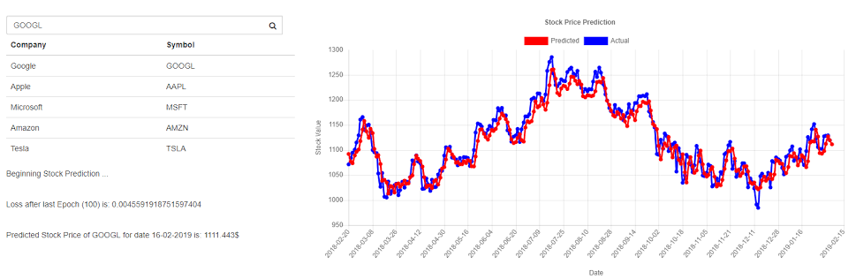

Fig 1

System Flowchart:

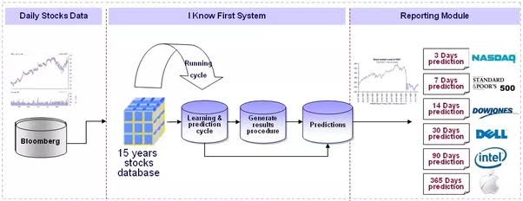

Fig 2

3.2 GENERAL OVERVIEW

Machine learning has many applications, one of which is to forecast time series. One of the most interesting (or perhaps most profitable) time series to predict are, arguably, stock prices.
Recently I read a blog post applying machine learning techniques to stock price prediction. It is a well-written article, and various techniques were explored. However, I felt the problem could be handled with a bit more academic rigor. For example, in the article the methods “Moving Average”, “Auto ARIMA” and “Prophet” had a forecast horizon of 1 year, whereas “Linear Regression”, “k-Nearest Neighbours”, and “Long Short Term Memory (LSTM)” had a forecast horizon of 1 day. Towards the end of the article, it is stated: “LSTM has easily outshone any algorithm we saw so far.” But clearly, we are not comparing apples to apples here.

The flow diagram of Figure 3.1 depicts the systems operation.

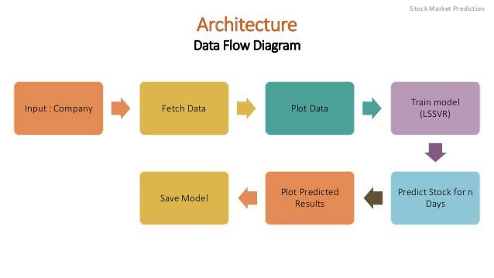

Fig 3

3.3 SYSTEM ARCHITECTURE

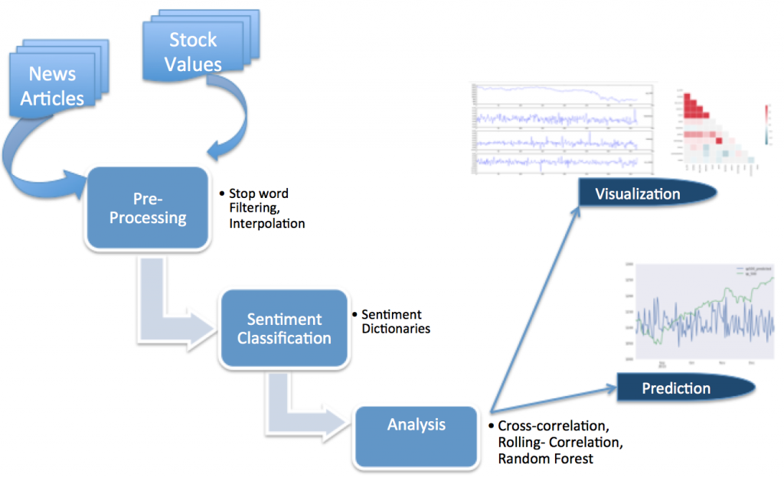

Fig 4

3.4 IMPLEMENTATION METHODOLOGY

This project seeks to utilize Deep Learning models, Long-Short Term Memory (LSTM) Neural Network algorithm, to predict stock prices. For data with timeframes recurrent neural networks (RNNs) come in handy but recent researches have shown that LSTM, networks are the most popular and useful variants of RNNs.
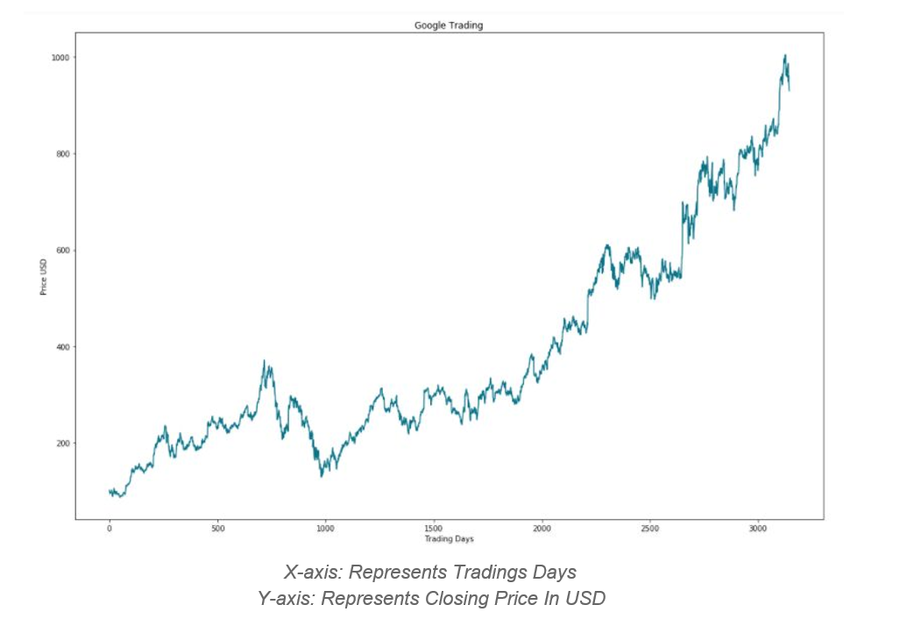
Fig 5

3.5 USE-CASE DIAGRAM AND DATA FLOW DIAGRAM

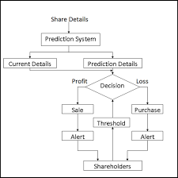
Fig 3.5.1 Use Case Diagram for the above proposed module

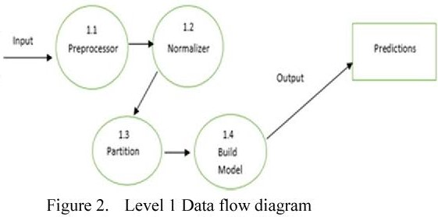

Fig 3.5.2 Data Flow Diagram

3.6 TOOLS USED

- Python
- Spyder IDE
- Numpy
- Pandas
- Matplotlib
- Tensorflow
- Keras

3.7 HARDWARE AND SOFTWARE REQUIREMENTS

The hardware and software requirements are as follows:

- Hardware:

  - Memory: 1GB RAM
  - Storage: 20GB
  - Processor: i3

- Software:

  - Windows 10
  - Python IDE
  - Anaconda: Spyder
  - Support libraries: Pandas, Numpy, etc.

CHAPTER 4

SYSTEM FEATURES

4.1 DATA PREPARATION

The stock prices is a time series of length NN, defined as p0,p1,…,pN−1p0,p1,…,pN−1 in which pipi is the close price on day ii, 0≤i<N0≤i<N. Imagine that we have a sliding window of a fixed size w (later, we refer to this as input size) and every time we move the window to the right by size w, so that there is no overlap between data in all the sliding windows.
The RNN model we are about to build has LSTM cells as basic hidden units. We use values from the very beginning in the first sliding window W0W0 to the window WtWt at time tt :
W0=(p0,p1,…,pw−1)W1=(pw,pw+1,…,p2w−1)…Wt=(ptw,ptw+1,…,p(t+1)w−1)W0=(p0,p1,…,pw−1)W1=(pw,pw+1,…,p2w−1)…Wt=(ptw,ptw+1,…,p(t+1)w−1)
To predict the prices in the following window wt+1wt+1:
Wt+1=(p(t+1)w,p(t+1)w+1,…,p(t+2)w−1)Wt+1=(p(t+1)w,p(t+1)w+1,…,p(t+2)w−1)

Essentially we try to learn an approximation function, f(W0,W1,…,Wt)≈Wt+1f(W0,W1,…,Wt)≈Wt+1 .

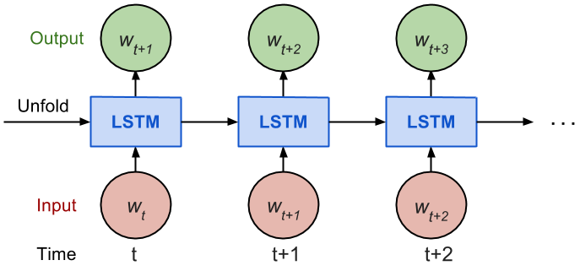
Fig. The unrolled version of RNN.
Considering how back propagation through time (BPTT) works, we usually train RNN in a “unrolled” version so that we don’t have to do propagation computation too far back and save the training complication.
Here is the explanation on num_steps from TensorFlow’s tutorial:
By design, the output of a recurrent neural network (RNN) depends on arbitrarily distant inputs. Unfortunately, this makes backpropagation computation difficult. In order to make the learning process tractable, it is common practice to create an “unrolled” version of the network, which contains a fixed number (num_steps) of LSTM inputs and outputs. The model is then trained on this finite approximation of the RNN. This can be implemented by feeding inputs of length num_steps at a time and performing a backward pass after each such input block.
The sequence of prices are first split into non-overlapped small windows. Each contains input_size numbers and each is considered as one independent input element. Then any num_steps consecutive input elements are grouped into one training input, forming an “un-rolled” version of RNN for training on Tensorflow. The corresponding label is the input element right after them.
For instance, if input_size=3 and num_steps=2, my first few training examples would look like:
Input1=[[p0,p1,p2],[p3,p4,p5]],Label1=[p6,p7,p8]Input2=[[p3,p4,p5],[p6,p7,p8]],Label2=[p9,p10,p11]Input3=[[p6,p7,p8],[p9,p10,p11]],Label3=[p12,p13,p14]Input1=[[p0,p1,p2],[p3,p4,p5]],Label1=[p6,p7,p8]Input2=[[p3,p4,p5],[p6,p7,p8]],Label2=[p9,p10,p11]Input3=[[p6,p7,p8],[p9,p10,p11]],Label3=[p12,p13,p14]

Here is the key part for formatting the data:
1  2  3  4  5  6 | seq = [np.array(seq[i * self.input_size: (i + 1) * self.input_size])  for i in range(len(seq) // self.input_size)]  # Split into groups of `num_steps`  X = np.array([seq[i: i + self.num_steps] for i in range(len(seq) - self.num_steps)])  y = np.array([seq[i + self.num_steps] for i in range(len(seq) - self.num_steps)])
The complete code of data formatting is here.

Train / Test Split
Since we always want to predict the future, we take the latest 10% of data as the test data.

Normalization
The S&P 500 index increases in time, bringing about the problem that most values in the test set are out of the scale of the train set and thus the model has to predict some numbers it has never seen before. Sadly and unsurprisingly, it does a tragic job. See Fig. 3.
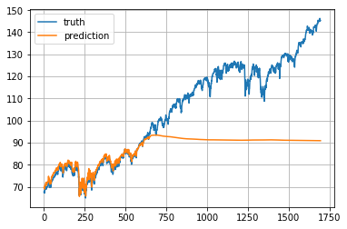
Fig. A very sad example when the RNN model have to predict numbers out of the scale of the training data.
To solve the out-of-scale issue, I normalize the prices in each sliding window. The task becomes predicting the relative change rates instead of the absolute values. In a normalized sliding window W′tWt′ at time tt, all the values are divided by the last unknown price—the last price in Wt−1Wt−1:
W′t=(ptwptw−1,ptw+1ptw−1,…,p(t+1)w−1ptw−1)Wt′=(ptwptw−1,ptw+1ptw−1,…,p(t+1)w−1ptw−1)

4.2 MODEL CONSTRUCTION

Definitions :
- lstm_size: number of units in one LSTM layer.
- num_layers: number of stacked LSTM layers.
- keep_prob: percentage of cell units to keep in the dropout operation.
- init_learning_rate: the learning rate to start with.
- learning_rate_decay: decay ratio in later training epochs.
- init_epoch: number of epochs using the constant init_learning_rate.
- max_epoch: total number of epochs in training
- input_size: size of the sliding window / one training data point
- batch_size: number of data points to use in one mini-batch.
The LSTM model has num_layers stacked LSTM layer(s) and each layer contains lstm_size number of LSTM cells. Then a dropout mask with keep probability keep_prob is applied to the output of every LSTM cell. The goal of dropout is to remove the potential strong dependency on one dimension so as to prevent overfitting.
The training requires max_epoch epochs in total; an epoch is a single full pass of all the training data points. In one epoch, the training data points are split into mini-batches of size batch_size. We send one mini-batch to the model for one BPTT learning. The learning rate is set to init_learning_rate during the first init_epoch epochs and then decay by learning_rate_decay during every succeeding epoch.
1  2  3  4  5  6  7  8  9  10  11  12  13  14 | # Configuration is wrapped in one object for easy tracking and passing.  class RNNConfig():  input_size=1  num_steps=30  lstm_size=128  num_layers=1  keep_prob=0.8  batch_size = 64  init_learning_rate = 0.001  learning_rate_decay = 0.99  init_epoch = 5  max_epoch = 50  config = RNNConfig()

Define Graph
A tf.Graph is not attached to any real data. It defines the flow of how to process the data and how to run the computation. Later, this graph can be fed with data within a tf.session and at this moment the computation happens for real.
— Let’s start going through some code —
(1) Initialize a new graph first.
1  2  3 | import tensorflow as tf  tf.reset_default_graph()  lstm_graph = tf.Graph()
(2) How the graph works should be defined within its scope.
1 | with lstm_graph.as_default():
(3) Define the data required for computation. Here we need three input variables, all defined as tf.placeholder because we don’t know what they are at the graph construction stage.
- inputs: the training data X, a tensor of shape (# data examples, num_steps, input_size); the number of data examples is unknown, so it is None. In our case, it would be batch_size in training session. Check the input format example if confused.
- targets: the training label y, a tensor of shape (# data examples, input_size).
- learning_rate: a simple float.
1  2  3  4  5  6  7  8  9 | # Dimension = (  # number of data examples,  # number of input in one computation step,  # number of numbers in one input  # )  # We don't know the number of examples beforehand, so it is None.  inputs = tf.placeholder(tf.float32, [None, config.num_steps, config.input_size])  targets = tf.placeholder(tf.float32, [None, config.input_size])  learning_rate = tf.placeholder(tf.float32, None)
(4) This function returns one LSTMCell with or without dropout operation.
1  2  3  4 | def _create_one_cell():  return tf.contrib.rnn.LSTMCell(config.lstm_size, state_is_tuple=True)  if config.keep_prob < 1.0:  return tf.contrib.rnn.DropoutWrapper(lstm_cell, output_keep_prob=config.keep_prob)
(5) Let’s stack the cells into multiple layers if needed. MultiRNNCell helps connect sequentially multiple simple cells to compose one cell.
1  2  3  4 | cell = tf.contrib.rnn.MultiRNNCell(  [_create_one_cell() for _ in range(config.num_layers)],  state_is_tuple=True  ) if config.num_layers > 1 else _create_one_cell()
(6) tf.nn.dynamic_rnn constructs a recurrent neural network specified by cell (RNNCell). It returns a pair of (model outpus, state), where the outputs val is of size (batch_size, num_steps, lstm_size) by default. The state refers to the current state of the LSTM cell, not consumed here.
1 | val, _ = tf.nn.dynamic_rnn(cell, inputs, dtype=tf.float32)
(7) tf.transpose converts the outputs from the dimension (batch_size, num_steps, lstm_size) to (num_steps, batch_size, lstm_size). Then the last output is picked.
1  2  3  4  5 | # Before transpose, val.get_shape() = (batch_size, num_steps, lstm_size)  # After transpose, val.get_shape() = (num_steps, batch_size, lstm_size)  val = tf.transpose(val, [1, 0, 2])  # last.get_shape() = (batch_size, lstm_size)  last = tf.gather(val, int(val.get_shape()[0]) - 1, name="last_lstm_output")
(8) Define weights and biases between the hidden and output layers.
1  2  3 | weight = tf.Variable(tf.truncated_normal([config.lstm_size, config.input_size]))  bias = tf.Variable(tf.constant(0.1, shape=[config.input_size]))  prediction = tf.matmul(last, weight) + bias
(9) We use mean square error as the loss metric and the RMSPropOptimizer algorithm for gradient descent optimization.
1  2  3 | loss = tf.reduce_mean(tf.square(prediction - targets))  optimizer = tf.train.RMSPropOptimizer(learning_rate)  minimize = optimizer.minimize(loss)

CHAPTER 5

OTHER NONFUNCTIONAL REQUIREMENTS

5.1 PERFORMANCE REQUIREMENTS

The performance requirements for this system includes:
• Input Parameters
• Preprocessing and Normalization (see Data Preprocessing Section)
• Neural Network Architecture
• Number of Layers (how many layers of nodes in the model; used 3)
• Number of Nodes (how many nodes per layer; tested 1,3,8, 16, 32, 64)
• Training Parameters
• Training / Test Split (how much of dataset to train versus test model on; kept constant at 82.95% and 17.05% for benchmarks and lstm model)
• Validation Sets (kept constant at 0.05% of training sets)
• Batch Size (how many time steps to include during a single training step kept at 1 for basic lstm model and at 512 for improved lstm model)
• Optimizer Function (which function to optimize by minimizing error; used “Adam” throughout)

5.2 ADVANTAGES AND DISADVANTAGES

Advantages:

Wow! The LSTM model can be tuned for various parameters such as changing the number of LSTM layers, adding dropout value or increasing the number of epochs. But are the predictions from LSTM enough to identify whether the stock price will increase or decrease? Certainly not!
As I mentioned at the start of the article, stock price is affected by the news about the company and other factors like demonetization or merger/demerger of the companies. There are certain intangible factors as well which can often be impossible to predict beforehand.
Disadvantages:

This project though predicts closing prices with very minimum Mean Squared Error, still there are many things that are lagging in this project. Two of most important things are There is no user interaction or interface provided in this project. A UI can be provided where user can check the value for future dates. The stocks used for this project are only of Alphabet Inc, we can surely add more S&P 500 in the list so as to make this project more comprehensive. I would definitely like to add these improvements to this project in future.

5.3 CHALLENGES

- A lot of time was spent on choosing the input size and LSTM size variables.
- Lack of proper tutorials for LSTM RNN models.

5.4 APPLICATIONS

- We were able to build a sufficiently accurate model that can analyze common stock trends and make predictions.
- Although not very feasible in the real market, this project is a start for us into finance analytics.

5.5 SOFTWARE QUALITY ATTRIBUTES

Following factors are used to measure software development quality. Each attribute can be used to measure the product performance. These attributes can be used for Quality assurance as well as Quality control.

- Reliability

Measure if product is reliable enough to sustain in any condition. Should give consistently correct results. This model is reliable, yet at some cases it fails. When any two faces of the same edge structure happen to appear, it might give wrong results, for which it is yet not implemented at industrial standards. Also, this system fails sometimes when predicting faces in different light conditions.

- Maintainability

Different versions of the product should be easy to maintain. For development it should be easy to add code to existing system, should be easy to upgrade for new features and new technologies time to time. Maintenance should be cost effective and easy. The developed system is easy to maintain and correcting defects or making a change in the software.

- Usability

This can be measured in terms of ease of use. Application should be user friendly. Should be easy to learn. Navigation should be simple.

- Efficiency

To Major system quality attribute. Measured in terms of time required to complete any task given to the system. For example, system should utilize processor capacity, disk space and memory efficiently. The developed system is efficient enough as it works faster with good RAM size and consumes disk space that is justified.

Hence, these were some of the software quality measurement attributes of the developed system.

CHAPTER 6

CONCLUSION AND FUTURE WORK

6.1 CONCLUSION

I have discussed all the important features of the datasets and their visualisation in one of the above sections. But to conclude my report i would choose my final model visualization, which is improved version of LSTM by fine tuning parameters. As i was very impressed on seeing how close i have gotten to the actual data, with a mean square error of just 0.0009. It was an ‘Aha!’ moment for me as i had to poke around a lot. But it was fun working on this project.

6.2 SCOPE OF FUTURE WORK

As a future direction, this research would like to perform a comparative analysis with deep learning classifiers and extreme learning classifiers with the help of a feature reduction algorithm based on the parameters used for stock market prediction. Along with this, research would also like to study and implement economic growth model for stock market prediction and the analysis of how economic growth model will affect in stock market prediction in comparison to the linear regression model and with specialized machine learning techniques.

REFERENCES

Attigeri, G.V., P.M.M. Manohara, R.M. Pai and A. Nayak, 2015. Stock market prediction: A big data approach. Proceedings of the IEEE Region 10th Conference on TENCON 2015, November 1-4, 2015, Macao, China, pp: 1-5.
Buche, A. and M.B. Chandak, 2016. Stock market prediction using text opinion mining: A survey. Int. J. Adv. Res. Comput. Sci. Software Eng., 6: 566-569.
Cheng, C.H. and Y.S. Chen, 2007. Fundamental analysis of stock trading systems using classification techniques. Proceedings of the International Conference on Machine Learning and Cybernetics, Volume 3, August 19-22, 2007, Hong Kong, China, pp: 1377-1382.
Dang, M. and D. Duong, 2016. Improvement methods for stock market prediction using financial news articles. Proceedings of the 2016 3rd National Foundation for Science and Technology Development Conference on Information and Computer Science (NICS), September 14-16, 2016, Danang, Vietnam, pp: 125-129.
Das, S.P. and S. Padhy, 2012. Support vector machines for prediction of futures prices in Indian stock market. Int. J. Comput. Applic., 41: 22-26.
Ding, X., Y. Zhang, T. Liu and J. Duan, 2015. Deep learning for event-driven stock prediction. Proceedings of the 24th International Joint Conference on Artificial Intelligence, July 25-31, 2015, AAAI Press, pp: 2327-2333.

